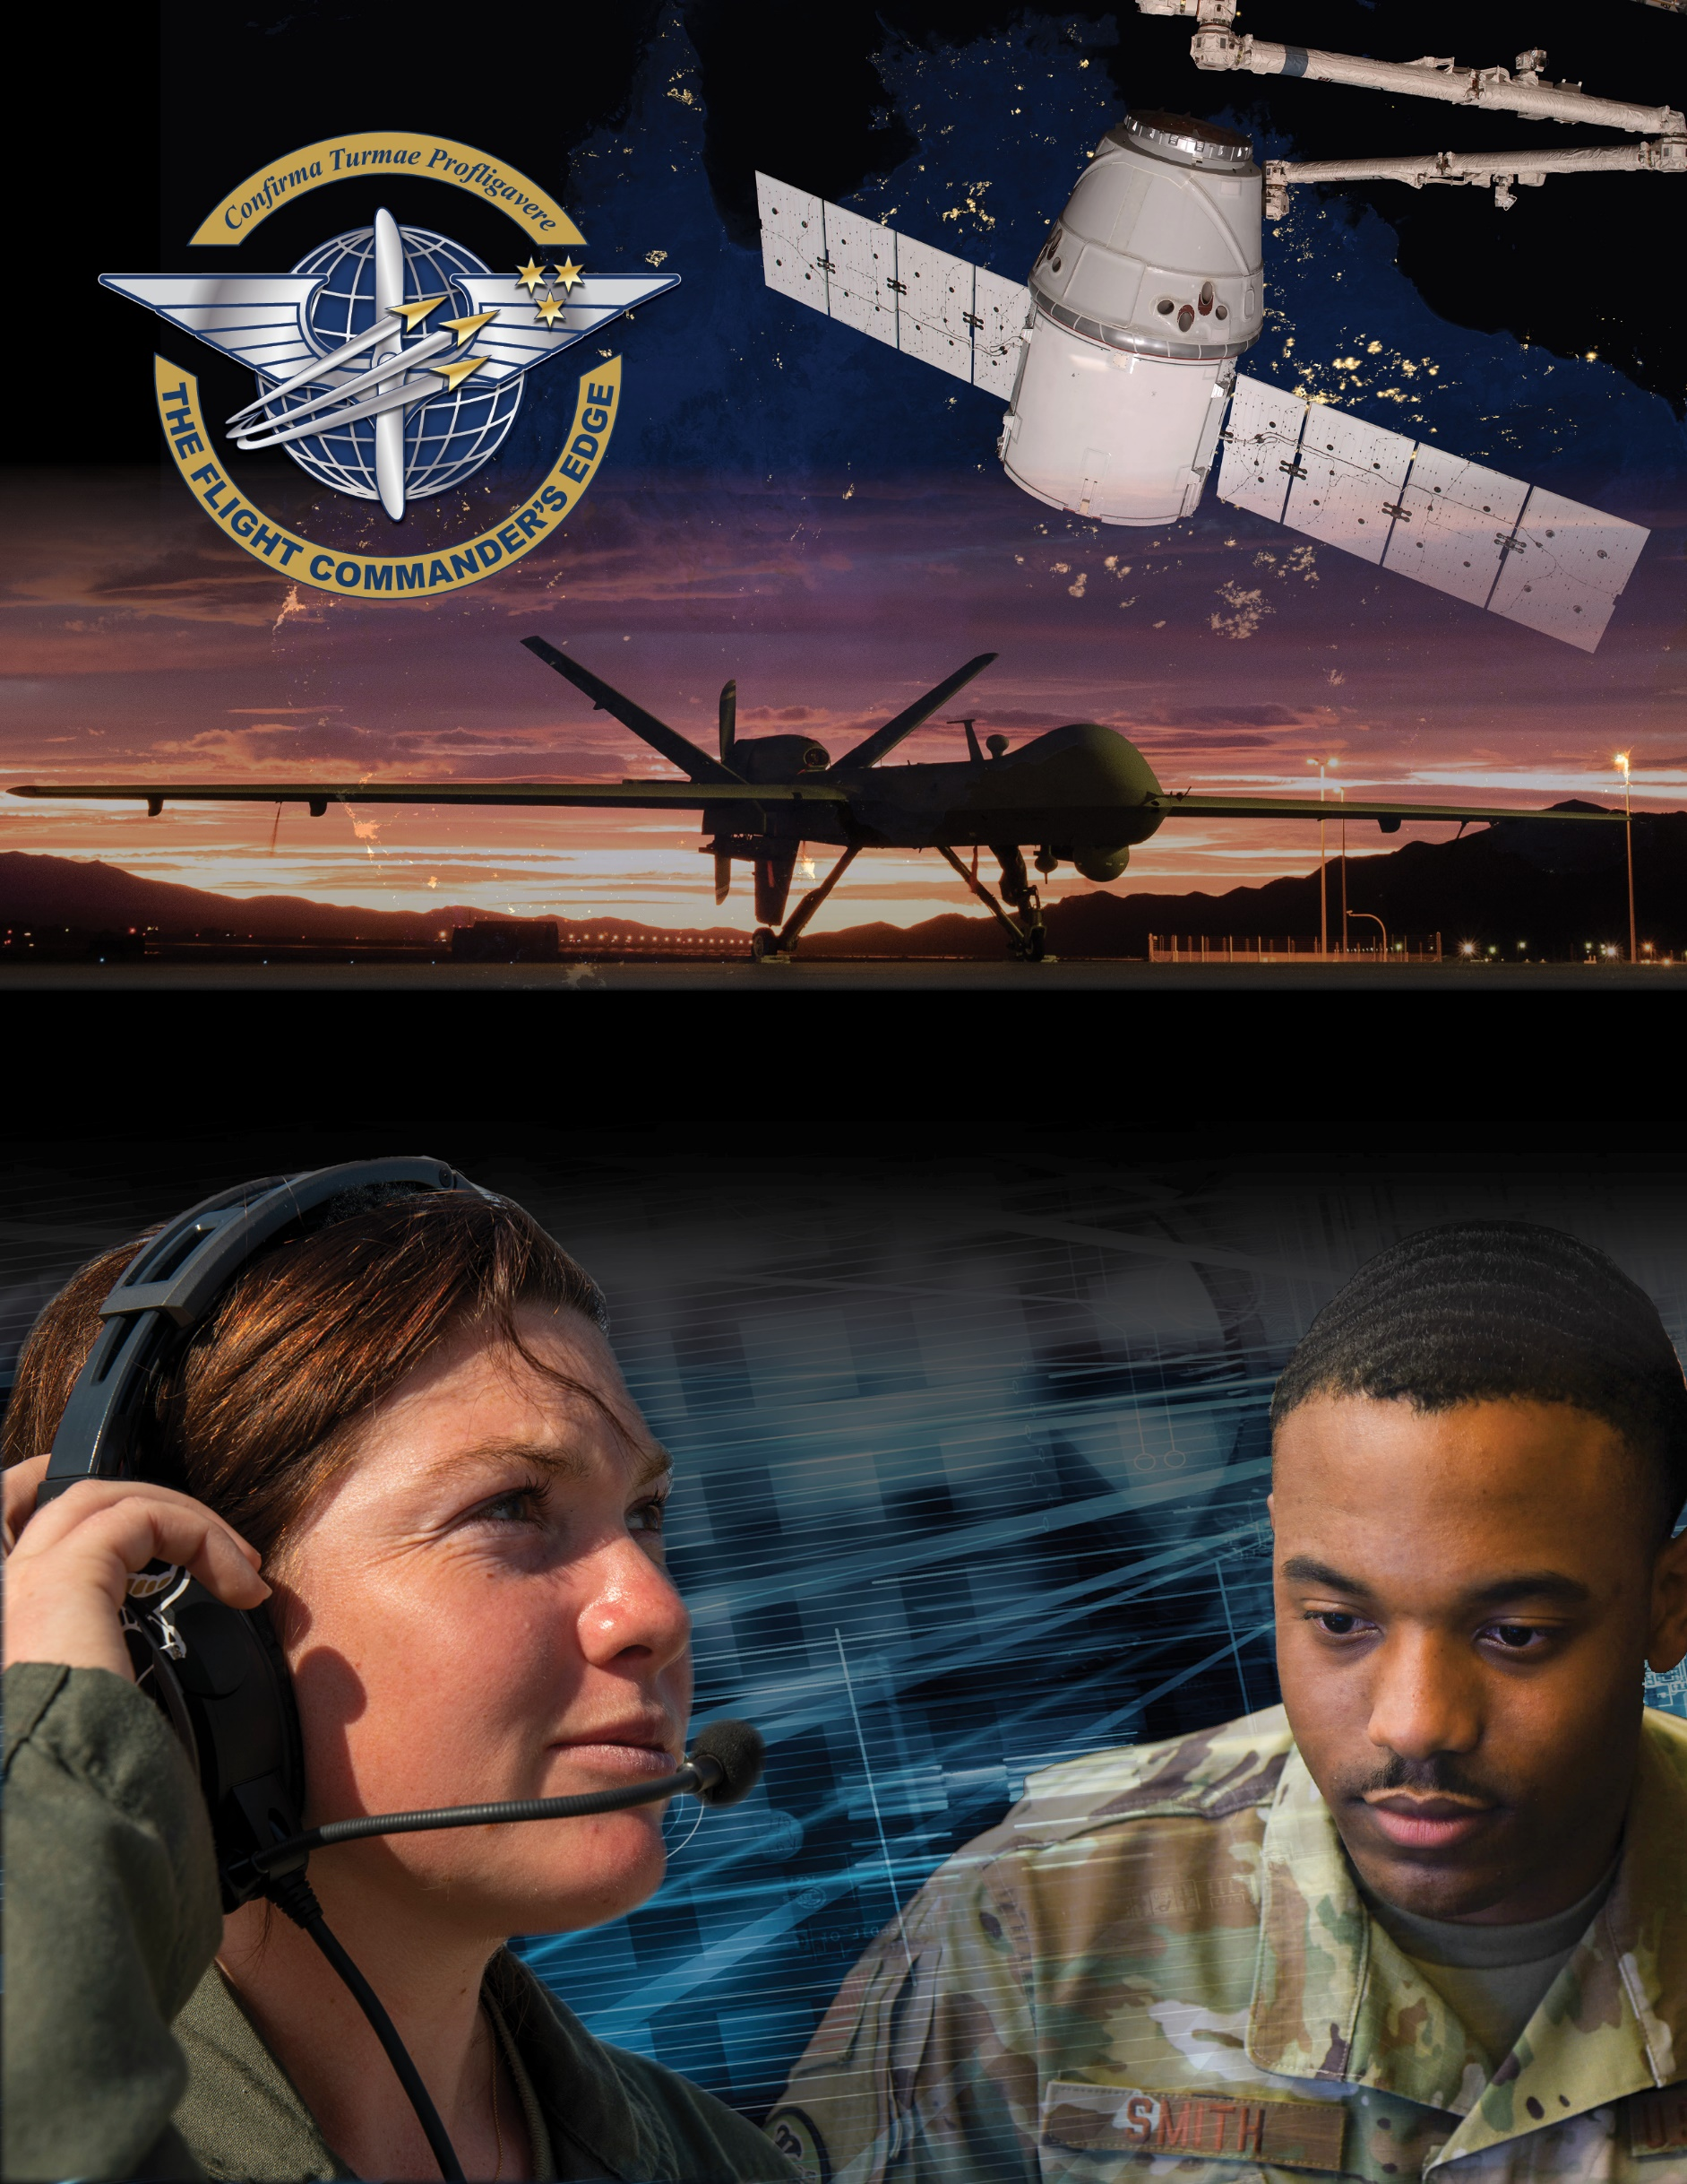

**Lesson Plan**



**Communication-in-Command**

***8 April 2025***

Table of Contents

About the Lesson 3

Before the Lesson 4

Presenting the Lesson 5

Appendix: Required Materials and Handouts 12

**How to Use this Lesson Plan**

This lesson plan is divided into three key sections and an appendix containing supporting material.

The **About the Lesson** section outlines the lesson and identifies requirements for its effective use. Course Directors should use this section to (a) understand the purpose and context of the lesson, (b) learn about lesson pre-requisites, and (c) guide the selection of facilitators.

The **Before the Lesson** section provides details on the preparation required for this lesson, including participant prerequisites (if any), recommended facilitator pre-course readings, and guidance on how to prepare the classroom.

The **Presenting the Lesson** section contains the actual lesson plan. It provides the recommended outline, discussion, and slide prompts along with actual *questions* and *recommended language* for the facilitator to use in the classroom.

The **Appendix** includes any required in-class handouts or exercise material.

For more information on how lessons are structured, or how to use them in the course, see the ***Course Director’s Handbook*** or ***Facilitator’s Resources***.

**Contact Us**

Email: [flightcommandersedge@us.af.mil](mailto:flightcommandersedge@us.af.mil)

Website: <https://www.airuniversity.af.edu/GCPME/Flight-Commanders-Edge/>

# About the Lesson

**Communication-in-Command**

## Overview

This lesson examines how communications requirements change when in a command role. The lesson begins by examining key examples of communications-in-command to help participants differentiate between communications requirements for commanders and non-commanders. Building on this distinction, the lesson identifies key skills and behaviors needed for command-level communication, and guides the participants to self-discover approaches to improve communication effectiveness. The lesson ends with a self-assessment designed to support future learning and growth.

## Objectives

By the end of this lesson, participants will be able to:

1. Differentiate between communications requirements for commanders and non-commanders.
2. Describe key skills and behaviors in effective command-level communication.
3. Identify approaches to improve communication effectiveness.

## Recommended Prerequisites

* None

## Recommended Time

* 50 minutes

## Recommended Facilitator Qualifications

This lesson is designed for a facilitator with the following minimum qualifications:

1. Subject matter knowledge
2. Command-level experience

Subject matter knowledge can be developed using the information presented in **Preparing the Facilitator** section of this document.

# Before the Lesson

## Preparing the Participant

* None. There is no pre-work for this lesson.

## Preparing the Facilitator

All required materials and participant preparation, plus:

* Center for Creative Leadership, [*Why Communication is so Important for Leaders*](https://www.ccl.org/articles/leading-effectively-articles/communication-1-idea-3-facts-5-tips/) (n.d.).

Note: This article is provided for information only. Use within this program does not constitute endorsement of the vendor nor its products by Air University.

(Optional) Additional deep-dive preparation materials are available on *The Flight Commander’s Edge* website.

## Preparing the Classroom

Ensure the classroom provides/is provisioned with:

* Adequate classroom space for separate small group discussions.
* Five white boards or easels with butcher block paper.
* Computer and projector (internet connectivity not required).

## Preparing Required Materials

Prepare one copy of each handout below for each participant. Do not distribute handouts before the class.

* Global College of PME, *Five Skills for Communication-in-Command*
* Global College of PME, *Enhancing Your Communication Skills Worksheet*
* Global College of PME, *Communication-in-Command Self-Assessment Worksheet*

Handouts are available in the Appendix.

# Presenting the Lesson

***NOTE:*** *This lesson is designed for up to five (5) groups of participants. Groups should be no larger than five (5) members to maximize participation during small group discussion.*

## Introduction (5 minutes)

The introduction to the lesson sets the stage for future learning through a group discussion on the effectiveness of communication-in-command.

### Slide 1: Communication-in-Command

Introduce the lesson.

**As a flight commander, the ability to communicate is critical. In this lesson, we will examine how communication requirements have (or will) change with command, and what you can do to ensure more effective communications in your day-to-day work.**

### Slide 2: Objectives

This slide lists the lesson objectives.

After participants have reviewed the lesson objectives, continue.

### Slide 3: Small Group Discussion

Divide the participants into small groups (4 or 5 members) and prompt the participants with the following experience.

**In your small groups, take five (5) minutes to share your experiences and discuss:**

**Examples of leaders who did (or did not) speak, write, or listen effectively.**

**How did these leaders’ (in)ability to communicate affect the mission?**

Monitor participants’ discussions for activity. Attempt to determine if each group was able to provide at least one example among its members.

After five (5) minutes, continue.

## Initial Discussion (10 minutes)

The initial discussion builds on the small group discussion in the introduction and stresses the importance of good communication. The discussion ends with the participants self-discovering the requirements for effective communication.

### (Optional) Slide 4: What Did You Learn?

If ALL small group discussions above failed to provide at least one example OR to include a large group discussion, continue.

Create a common experience by having one or two group members share their examples. This sets the stage for group members to answer the discussion questions in the next section.

**Ok, that may have been a hard question.**

**Would one or two of you care to briefly share your examples with the larger group? I’d like everyone to have at least one good (or bad) example of how communications affected the mission.**

**In the interest of academic freedom, please do not share real names or other identifiable information.**

Allow group members to share their stories. Monitor presentations to keep them brief. The goal is to ensure everyone in the course hears at least one good example of how a leader was successful (or unsuccessful) at communication, and how that affected the mission.

Participants may focus on oral communication but try to bring out examples of written communications as well.

After the entire group has heard at least one good (or bad) example, continue.

### Slide 5: What Did You Learn?

Ask the following questions to the large group.

**What key things did you learn about communications – at the command level – from your group discussions?**

**How does communication change when “in command”?**

Anticipated Responses: Answers will vary, but should focus on…

* Communication is hard.
* Good communication skills can help the mission; bad skills can derail it.
* It is critical for commanders to be effective communicators.

After a brief discussion, continue.

### Slide 6: What Did You Learn?

Ask the following question to the large group.

**What does it mean when we say a commander needs to be an *effective communicator*?**

Anticipated Responses: A commander must…

* Have good relationships with others (interpersonal skills)
* Speak well (oral communications)
* Write well (written communications)
* Ensure messages are clear and correctly received (shared understanding)
* Listen well and ensure all parties are heard (candid communications)

Guide the discussion to end on the concept of creating shared understanding. This is the most critical communication skill for any commander. We will look at each of these in the next section.

After a brief discussion, continue.

## Content Presentation (5 minutes)

The previous discussion focused on key communications skills for commanders. Now we will examine each of these skills and define some key behaviors associated with each. This brief activity prepares the group for the next section.

Distribute the Global College of PME**, *Five Skills for Communication-in-Command*** document.

When complete, continue.

### Slide 7: Five Skills for Communication-in-Command

Introduce the skills and associated behaviors by stating the following:

**In the last discussion, we talked about the skills needed for effective communications in command. The Global College of PME has outlined five of these skills in more detail as shown here on this slide and on your handout.**

**Let’s take a few minutes and look at these.**

**The handout shows each skill and a selection of behaviors that are important to those skills. There are many more behaviors associated with each, but these are the ones potentially most important to command.**

**In your small groups, take a moment to review the skills and behaviors.**

**Discuss the skills and behaviors in your groups for about five (5) minutes and develop a “shared understanding” of their definitions. When you are sure you understand what each means to you, we will move onto the next activity.**

As the facilitator, you should be prepared to address any confusion on the skills and behaviors not resolved in the small groups.

After five (5) minutes, continue.

## Application Activity (25 minutes)

Now that we have defined the key communication skills and behaviors for commanders, this section employs a wisdom-of-the-crowd approach to identifying ways for improvement. At the end of the exercise, participants should have comprehensive list of tips that can be applied to become a more effective communicator.

Prepare the classroom by setting up five (5) easels with butcher paper, or five (5) white board segments.

Across the top of each of the paper or boards, write one of the key communications skills:

*Develop Good Interpersonal Skills*

*Develop Oral (Spoken) Communications*

*Develop Written Communications*

*Create Shared Understanding*

*Encourage Candid Communications*

After the room is prepared, continue.

### Slide 8: Enhancing Your Communication Skills

Begin the exercise with the following directions.

**Now that we’ve defined the key communication skills and behaviors that commanders must demonstrate, the question is: How do you get better at them?**

**It would be possible to teach a lengthy course on each of these skills, but we – as commanders – don’t have that kind of time. What we do have time for is helping each other out. That is what we are going to do now.**

Distribute the Global College of PME**, *Enhancing Your Communication Skills Worksheet*** to all participants. This worksheet contains some prepared tips for improving in each area, and space for participants to record tips they come up with during the exercise.

When complete, continue.

**The handout provides some basic methods to improve in each of these areas.**

**In your small groups, go up to one of the boards. Over the next four (4) minutes, brainstorm more methods to improve in the skill you’ve chosen. Write your ideas on the paper/board.**

**After four (4) minutes, I’ll have you rotate to the next board. We will repeat this until each group has had a turn at each of the boards.**

Begin the exercise and monitor for time. Do not let the groups go longer than four (4) minutes.

After all rotations are complete, continue.

### Slide 9: Enhancing Your Communication Skills

Continue the discussion.

Take a few minutes (no more than 5 minutes total) to summarize the suggested methods to improve. Ask clarification questions of the groups if required. Remind participants to record tips and ideas they may want to explore or apply in the future on the handout.

## Lesson Wrap-Up (5 minutes)

The final lesson activity is a self-assessment of effective communication behaviors. This activity feeds the final lesson in the course – *The Road Ahead* – and will be used to support the development of the participants’ personal development plan.

Distribute the Global College of PME**, *Communication-in-Command Self-Assessment Worksheet*** to all participants.

When complete, continue.

### Slide 10: Self-Assessment

Initiate the self-assessment and wrap up the lesson.

**Now that you have had the opportunity to consider how communication is different in command, to learn about the key command-level communications behaviors, and develop strategies for improving your communication skills, it’s time for the next logical step: a self-assessment.**

**The *Communication-in-Command Self-Assessment Worksheet* is designed to help you plan for your future. The instructions are self-explanatory. Take a moment to read them, then fill out the sheet. If you need more time, you can go into the break.**

**Keep this worksheet for reference. You will need it again for the last lesson of the course.**

End. Break (10 minutes).

# Appendix: Required Materials and Handouts

The materials required for this lesson include:

* Global College of PME, *Five Skills for Communication-in-Command Quick Reference Guide*
* Global College of PME, *Enhancing Your Communication Skills Worksheet*
* Global College of PME, *Communication-in-Command Self-Assessment Worksheet*

These handouts, on the following pages, are designed for printing directly from the lesson plan. Ensure you print enough copies for all class participants.

## Five Skills for Communication-in-Command

*Developed by the Global College of PME*

|  |  |
| --- | --- |
| Skills | Behaviors |
| **Interpersonal skills**  The skills used by a leader to interact with others in the flight. Can also be referred to as the ability to get along with others while getting the job done. | Build effective relationships  Inspire others  Demonstrate emotional intelligence  Build trust |
| **Written communications**  You will not always be able to speak to someone face-to-face, so effective written communication skills are vital. | Prepare influential documents  Demonstrate coherence  Demonstrate brevity  Demonstrate clarity |
| **Oral (spoken) communications**  Face-to-face communication is significant when building trust and rapport and is essential for teamwork within a flight. | Conduct influential dialogue  Employ active listening skills  Present unbiased ideas  Employ effective presentations |
| **Shared understanding**  A perspective shared by the group. This can be influenced by participation and collaboration on various tasks. | Present essential information  Coordinate with shareholders  Provide current information  Prepare for leader absence  Employ audience-appropriate methods  Demonstrate clarity to limit miscommunication |
| **Encourage candid communications**  Start by listening and encouraging others to talk. | Create a forum for people to raise questions  Learn how to have crucial conversations  Speak candidly yourself  Demonstrate you are willing to delay judgment  Give positive feedback – look and act interested  Keep confidences if information is sensitive  Share information with the speaker  Display a positive attitude  Ask questions |

## Enhancing Your Communication Skills

*Developed by the Global College of PME*

|  |  |  |
| --- | --- | --- |
| **Skills** | **How to Improve** | **Other Ways to Improve** |
| **Develop interpersonal skills** | **Increase self-awareness of how you come across when communicating.**   * Cultivate a positive outlook. * Control your emotions. * Acknowledge others’ expertise. * Show a real interest in your colleagues. * Find one good trait in every co-worker. * Practice active listening. * Be assertive. * Practice empathy. * Maintain good relationships.   Also, see the FCE *Emotional Intelligence* lesson. |  |
| **Develop written communications** | **Target your communication to serve the eight critical functions in an organization.**   * Directing actions * Coordinating effort * Building relationships * Explaining organizational culture * Coordinating inter-organizational efforts * Presenting/supporting the boss’ vision * Generating ideas * Promoting ideals and values   Read Kline, *Write Right* (see below). |  |
| **Develop oral communications** | **Develop a balance between talking and listening.**   * Be friendly and polite; build rapport * Focus on what is being said and respond appropriately * Use open-ended questions * Create emotional connections * Show interest and *be* interested   Read Kline, *Speaking Effectively* (see below). |  |
| **Create shared understanding** | **Ask questions and listen to answers.**  Shared understanding is essential because each member of a team enters with their own beliefs and understanding of both problems and processes. Teams are most effective when members agree on a shared set of goals and metrics. This understanding helps to minimize the impact and distraction of various biases, filters, and incomplete information.  How to do this: Ask lots of questions to ensure your message is received and understood correctly. Listening effectively is key to this skill.  Read Kline, *Listening Effectively* (see below). |  |
| **Encourage candid communications** | **Candor is critical to effective team leadership. Strive for candor in your communications by:**   * Identifying the purpose for your communication (“Why are we talking about this?”). * Selecting the right time and place for communication (deal with events sooner than later; avoid email if possible). * Invite dialogue (keep and open body language, state facts, avoid “you” statements). * Communicate facts first…then interpretations…then feelings. * Encourage others to share thoughts, concerns, feelings, and ideas. * Keep your emotions under control.   Read Kline, *Listening Effectively* (see below). |  |

### To Learn More:

Books and articles by Dr. John Kline, former Air University Chief Academic Officer:

*Write Right!* - [Available on The Free Library](https://www.thefreelibrary.com/Write+right!-a0430498003)

*Speaking Effectively* - <https://www.airuniversity.af.edu/Portals/10/AUPress/Books/AU-5.PDF>

*Listening Effectively* - <https://www.airuniversity.af.edu/Portals/10/AUPress/Books/AU-4.PDF>

## Communication-in-Command Self-Assessment Worksheet

*Developed by the Global College of PME*

This self-assessment provides an opportunity for you to assess your own leadership skills and behaviors. These skills and behaviors are based upon the concepts addressed within this lesson. *You will use these worksheets again during the final lesson of the course.*

NOTE:Not all these skills and behaviors were covered in this lesson, rather, they reflect what an ideal flight commander should know and be able to do in this topic area.

Rate yourself on a scale of 1-5 in each of the areas below:

5 – Needs No Improvement 3 – Average 1 – Needs Significant Improvement

| Competency | Skill | Behavior | Self-Assessment  (1-5) |
| --- | --- | --- | --- |
| Communicating | Develop interpersonal skills | Build effective relationships  Inspire others  Demonstrate emotional intelligence  Build trust |  |
| Communicating | Develop written communications | Prepare influential documents  Demonstrate coherence  Demonstrate brevity  Demonstrate clarity |  |
| Communicating | Develop oral (spoken) communications | Conduct influential dialogue  Employ active listening skills  Present unbiased ideas  Employ effective presentations |  |
| Communicating | Create shared understanding | Present essential information  Coordinate with shareholders  Provide current information  Prepare for leader absence  Employ audience-appropriate communication methods  Demonstrate clarity to limit mis-communication |  |
| Communicating | Encourage candid communications | Provide focused, respectful feedback  Display a positive attitude  Reinforce the expression of contrary and minority viewpoints  Guard against groupthink |  |

(See tips on reverse)

Some tips:

* Ask your supervisors, peers, and subordinates how they perceive your behaviors in these areas. Often we are biased toward ourselves, meaning we tend to rate ourselves better than others actually perceive us. In leadership we must strive to minimize the differential between how we think we behave and how others perceive our behaviors.

| My Notes |
| --- |
|  |